Hi Hogweeds,
Following on from the success of last year’s Hogweeds camping and trail running event it has been decided to organise a similar event this year. The dates to put in your calendars for this year will be 21st-23rd June.

Trail Run
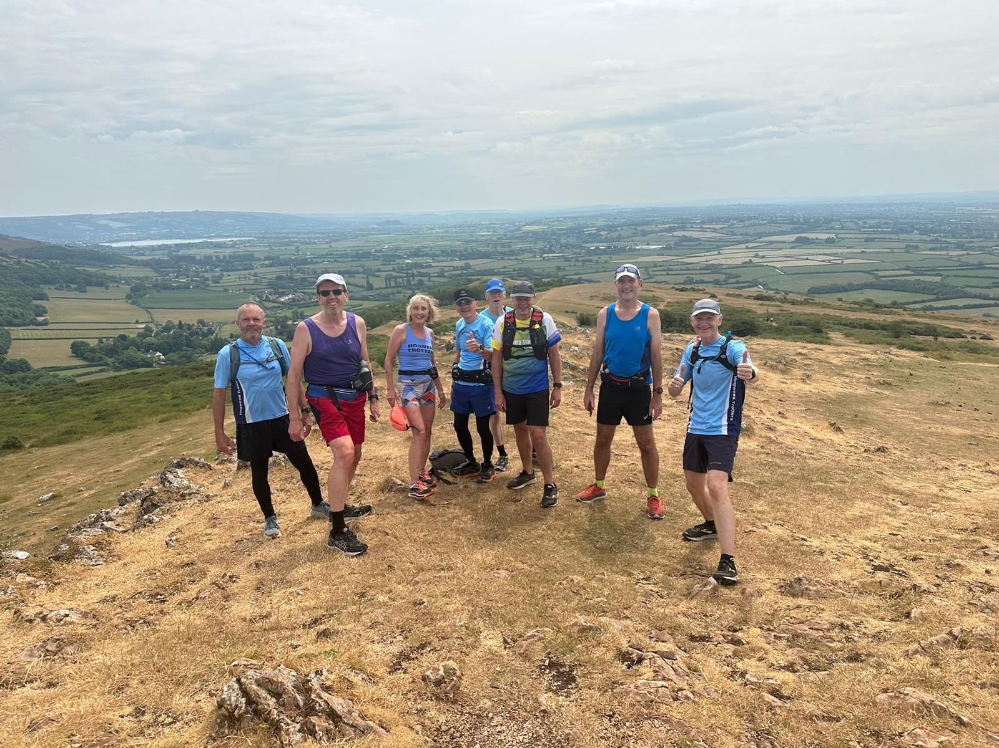
I would like to stress this event is open to all abilities the following descriptions are just an overview of what’s available on the trail. Last year there was a wide range of organised walks and runs for a wide range of abilities.
This year the route will encompass the remainder of the West Mendip Way from Wells to Cheddar which is approximately 11 miles. And, the East Mendip Way which is a further ~20Miles. These both are very picturesque trails. See Links below for more details of the actual route. This event is open to both Hogweeds and their families.

Download the old West Mendip Way Guide here (PDF Download 3MB) with OS maps and route descriptions.
Download the old East Mendip Way Guide here (PDF Download 3MB) with OS maps and route descriptions

This will be great training being just before Cotswold Relay. Or equally as good for those who just want to chill out in Somerset and soak in the atmosphere of Cheddar. The actual logistics of this event is dependent on participants taking part. However, I have created a preliminary Itinerary as suggested below, based on our experience gained from last time.
Initially I am thinking of having planned routes for Saturday Day 1- see possible options below and then deciding how people are feeling for the Sunday. Last year we all decided we would have a chilled walk around Cheddar reservoir.
Day 1- Distance (miles)
5 possible starting locations/distances (TBC)
Chillout in Cheddar 0 Miles
Priddy to Cheddar 5.49 Miles
Wells to Cheddar 11 Miles
Waterlip to Cheddar 20 Miles
Frome to Cheddar. 31.0 Miles

Day 2-
This will be discussed on the Saturday night around the camp fire.
Walk around Cheddar
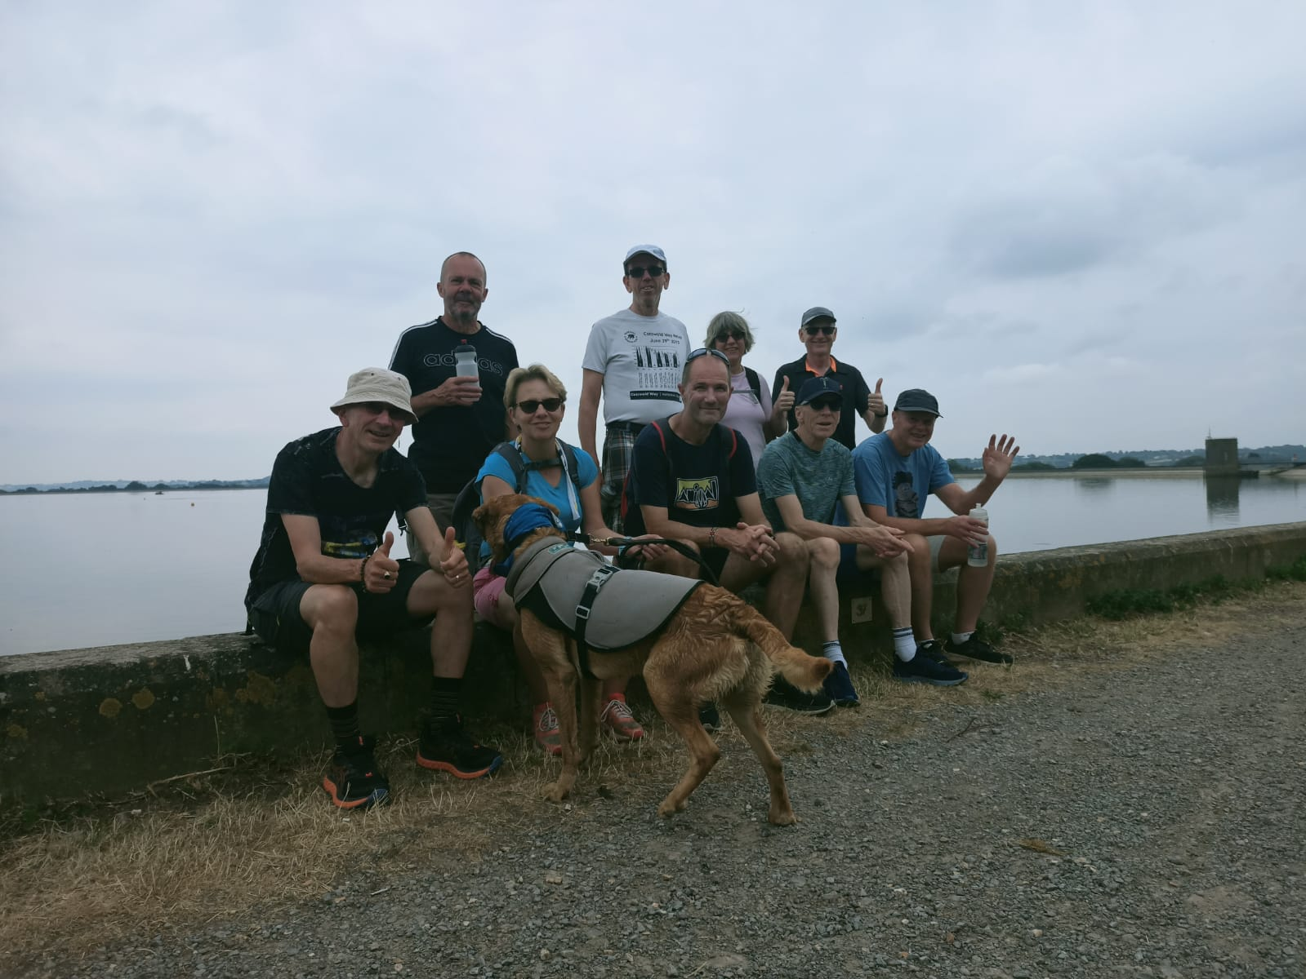
We will be using the same campsite in Cheddar as last year this can be booked for the Friday and Saturday or Saturday night only. However, those that don’t want to camp there is also the possibility of just turning up on either day and joining the group trail.

Hogweeds Pitches
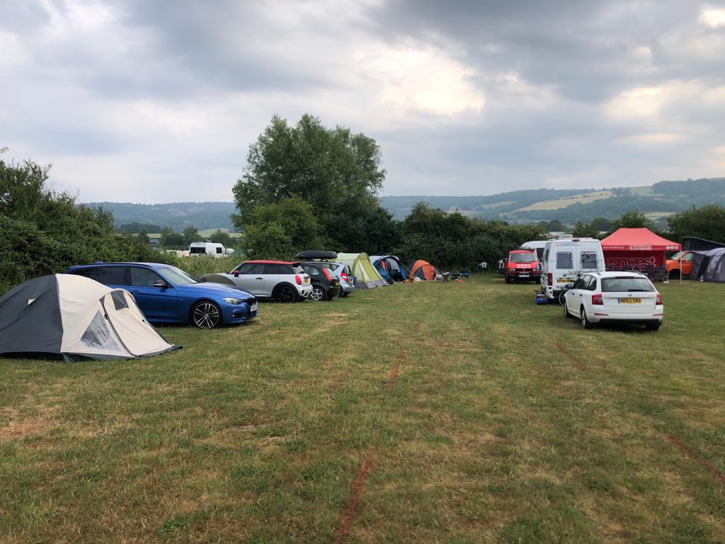
Campsite
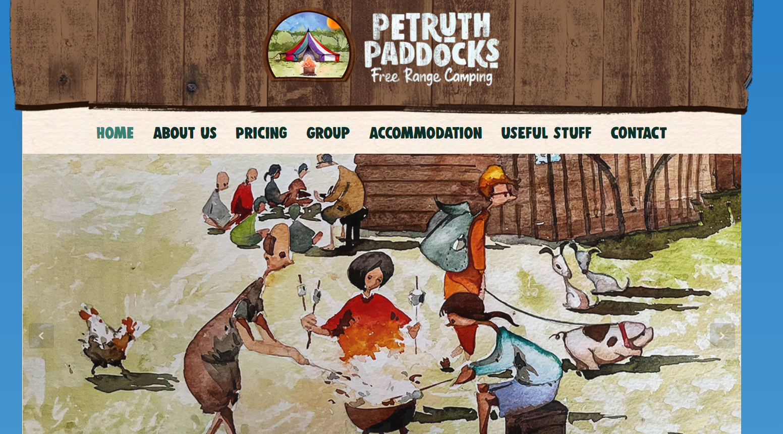

On the Saturday and Possibly Friday night we can either go into Cheddar for a bite to eat and a drink or weather permitting just sit around the campfire having a barbecue/food. Old Rosie’s Cider seemed popular last year along with the fire pit. Apparently, the fish and chips are also very good.
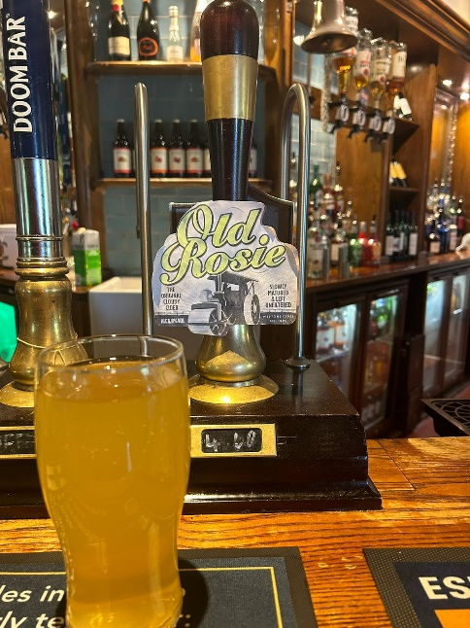

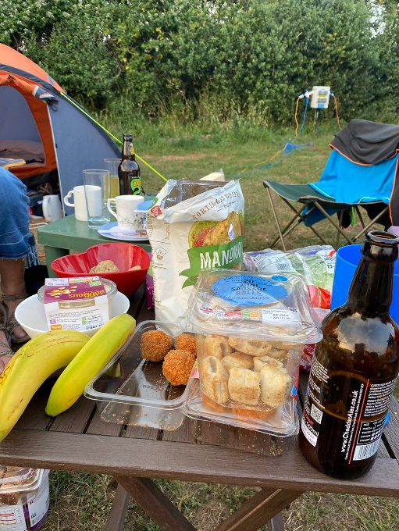

Also, Dogs are very Welcome.
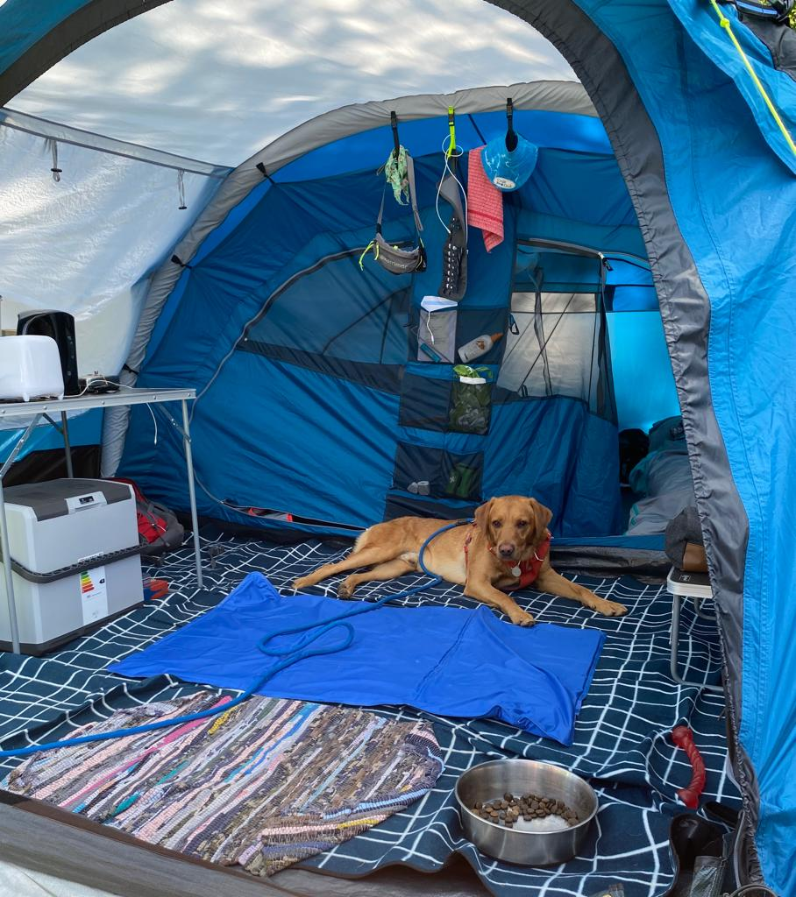

If you are interested, please let me know, so I can add you to the WhatsApp Group
HAPPY CAMPING

Thanks Steve and Team

